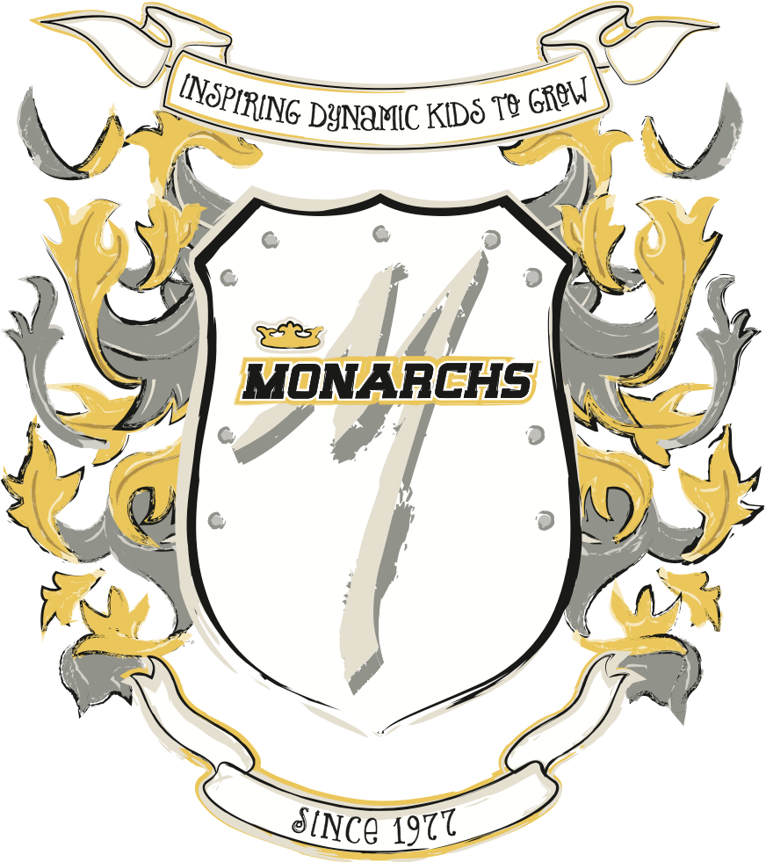
R102: Preschool Fundamentals: Hands On Training (HOTPS) “Quiz Answer Sheet”
Employee Name: ________________________________________

True or False:

- The purpose of warm-ups is to prepare the body for upcoming activities?

- Themes and lesson plans should NOT be followed, do your own thing.

- When spotting, make sure to break down skills into achievable steps and progressions.

- Music provides an instant connection with most children.

- It usually takes a child four times to understand the program.

- Children in a parent-child class know how to “take turns”.

- The trampoline does NOT require supervision at all times.

- The Toddler Property Laws all stem down to it mine, not yours!

Multiple Choice:
- What are good teaching principles?
- Prepare a safe class
- Take ownership and responsibility of your class and actions
- Make sure the children of children to coach is safe
- Follow the established lesson plans
- All of the above

- Locomotor skills include:
  - Walking
  - Running
  - Hopping
  - Skipping
  - All of the above

- What are type of activities should be included in a parent-child class?
  - Fine Motor skills
  - Group Activities
  - Large Motor Skills
  - Individual Activities
  - All of the above
Match the skill to the event:
- Run, punch on board with two feet, proper hurdle
- Walking forward, backwards, sideways, jump down to safety landing, dipwalks.
- Handstand walking feet up, Cartwheel, Donkey Kicks, Forward Roll, Backwards Roll.
- Hanging, Hand Shimmies, front support, front support forward roll with spot, pullover (walk feet up the block and with spot come over to front support)

Vault:

Bars:

Beam:

Floor:

